**Limp in children - facilitator guide**

INSTRUCTIONS FOR INTERACTIVE VOTING

1) Download meetoo addin for powerpoint in order to enable interactive voting:

<https://www.meetoo.com/resources/meetoo-powerpoint-add-ins/complete-powerpoint-add-in>

2) Open powerpoint presentation and start slideshow

3) Click “connect” 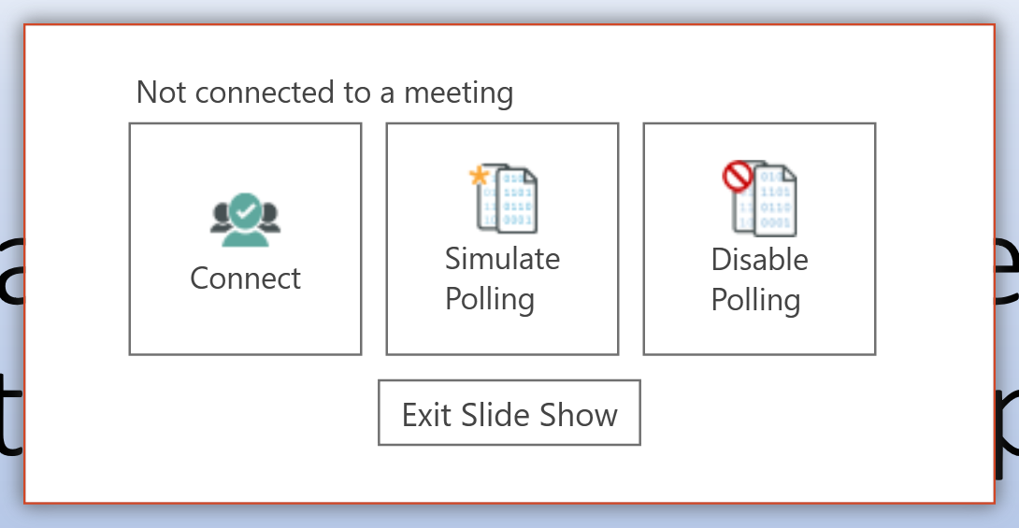

4) When asked to log in use email [Sanjay.patel@uhs.nhs.uk](mailto:Sanjay.patel@uhs.nhs.uk) and password healthiertogether.

5) Enter meeting ID **164-597-547**

6) Get delegates to log into **web.meetoo.com**  and enter Meeting ID **164-597-547**

7) Start the workshop.

**If you are unable to download the meetoo addin for Powerpoint:**

Alternative for interactive voting is for facilitator to log in to [www.meetoo.com](http://www.meetoo.com) – username [Sanjay.patel@uhs.nhs.uk](mailto:Sanjay.patel@uhs.nhs.uk) password healthiertogether – choose **limp workshop_primary care**, get delegates to log in (see below) and start polling by clicking play button at top :

and then each question in turn (will need to toggle between Powerpoint sides and meetoo website to allow voting)

Delegates to log into **web.meetoo.com**  and enter Meeting ID **161-798-463**

**Post course for delegates**

Signpost them to the feeding pathways on the healthier together website