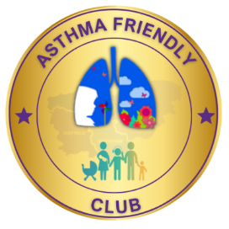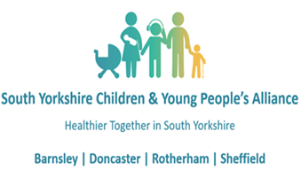

**Club Name**

**Asthma Friendly Club Charter**

**Name of Club Implementation Lead ………………………………………..**

**NHS South Yorkshire Contact:**

Dr Sonal Kansra, Clinical Lead for Children & Young People’s Asthma across the NHS South Yorkshire Integrated Care Systems and / or Specialist CYP Asthma Nurses at Place

Link here: [linktr.ee/sycypalliance](https://linktr.ee/sycypalliance) Email: [scn-tr.cypalliance@nhs.net](mailto:scn-tr.cypalliance@nhs.net)

**Aims**  
Asthma is the most common chronic childhood condition, affecting one in eleven children. On average, there are two pupils with asthma in every classroom in the UK and this results in over 25,000 emergency hospital admissions a year.

The South Yorkshire Asthma Friendly Clubs Initiative aims to improve the care of club members with asthma by raising awareness through information, training and support for leaders, volunteers, managers and coaches. The initiative builds on the work already undertaken across South Yorkshire by 0-19 Services and Paediatric Respiratory teams over many years.

**Our Club Pledge**

At **Club NAME**, we recognise that asthma is a common, serious, but controllable condition, and we welcome all children with asthma to join us. We want our club community to be healthy and happy. By educating our leaders, volunteers, managers and coaches around asthma and its treatment, we aim to enable club members to medicate effectively whilst at our club and for asthma to have as little an impact as possible on their activity and participation.

**As an Asthma Friendly Club, we will*:**

1. Ensure all club leaders, managers or coaches have completed the appropriate level of training to effectively deal with children and young people’s asthma.
2. Ensure leaders, managers or coaches are aware of those children with asthma under their care and as a club this information is available as a part of routine health information collected for the child or young person.
3. Ensure all children with asthma are included in activities they wish to participate in.
4. Have a process to allow quick and easy access to a child’s inhaler.
5. Always have information easily accessible to all managers/coaches/leaders on how to manage an asthma attack.
6. Have a process to escalate to parents where we have a concern about a child with asthma including if a child has used their inhaler.
7. Encourage our club locations to be designated smokefree areas.

*\*See Supporting information for asthma friendly clubs for advice and guidance on how your club can achieve the various steps required to accredit as an asthma friendly club*

**As a club we recognise the benefits to becoming an Asthma Friendly Club include**:

* Improved support to young people with asthma encouraging an inclusive environment.
* Improved asthma awareness to allow you to recognise and signpost children with poor asthma control.
* Enhancing the overall health, safety, and wellbeing of your young people.
* Increased confidence in managing children with breathing problems.
* Positive reputation for our club.
* Optimising young people's participation in our activities.

**All club leader, manager and coach responsibilities:**

All club leaders, managers and coaches should:

* Complete the appropriate level of training to effectively deal with children and young people’s asthma.
* Be aware of the Asthma Friendly Club Charter and commit to having an awareness of those children with asthma under their care.
* Ensure that club members have immediate access to their own inhalers.
* Always have information easily available on how to manage an asthma attack.
* Maintain effective communication with parents/carers, including informing them if their child has been unwell whilst at the club. Including if the child has needed to use their inhaler.
* Ensure all children with asthma are included in activities they wish to participate in.

V1.1 Mar 25