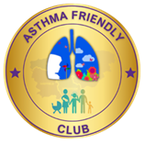

Dear Parent/Carer,

This letter is to make you aware that _____________________ has had problems with their breathing today.

This happened when________________________________________________________

* They used______ puffs of their own inhaler.
* They did not have their inhaler with them.

Although they soon felt better, we would strongly advise that you discuss this with their own doctor or asthma nurse as soon as possible.

Yours sincerely,

Signed: ____________________________ Date: _____________________

Print name: ______________________________

Child’s name: ______________________________

Please can you ensure your child brings a working in-date inhaler and spacer (if required) for their use when at the club: they should be clearly labelled with your child’s name and date of birth.