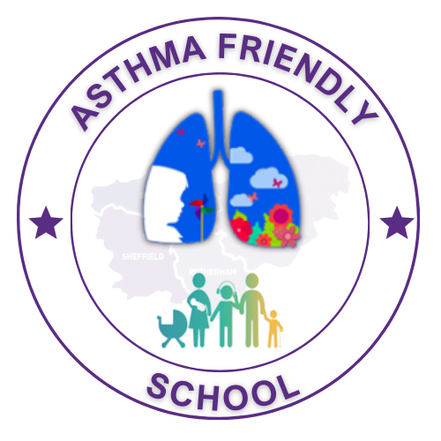

School Name

Asthma Policy

Name of School Asthma Lead:

NHS South Yorkshire Contact:

Dr Sonal Kansra, Clinical Lead for Children & Young People’s Asthma across the NHS South Yorkshire Integrated Care Systems and / or Specialist CYP Asthma Nurses at Place
linktr.ee/sycypalliance

scn-tr.cypalliance@nhs.net

Author: NHS South Yorkshire ICB CYP Asthma Transformation Core Group
(v4 – July 2023)
Acknowledgements: Healthy London Partnership

Aims
Asthma is the most common chronic childhood condition, affecting one in eleven children. On average, there are two pupils with asthma in every classroom in the UK and this results in over 25,000 emergency hospital admissions a year.
At SCHOOLS NAME, we recognise that asthma is a common, serious, but controllable condition, and we welcome all children with asthma to join us. We want our school community to be healthy and happy. By educating our staff around asthma and its treatment, we aim to enable pupils to medicate effectively in school and for asthma to have as little an impact as possible on their learning.

Objectives
We will ensure that all pupils who suffer from asthma:
- be linked with specified staff members who know them, their condition, their parents/guardians, and their medical care plan well;
- always have appropriate medicines stored in school (and held by a designated adult when on trips) at all times. Consent will be obtained from parents/guardians and added to the medical register.
- have full access to the curriculum including exercise and PE, educational visits, and residential trips, as far in advance as possible.

General Information
All pupils with asthma will be placed on an Asthma Register and encouraged to take control of their own medical needs when, and as far as appropriate (according to their age and the severity of their condition). Appendix 1 Asthma Register

The care and administration of medication to pupils with asthma will be incorporated in the planning and risk assessments around all school trips and visits.

Asthma Lead Name is the named staff member in our schools who oversees the implementation of this policy.

Medical Support and Liaison

We follow a regionally endorsed Asthma Management Plan which sets out the response in the event of a pupil suffering from an asthma attack.

Exceptionally, for pupils where this plan is not appropriate, an individualised Medical Care Plan which incorporates guidance about what to do in the case of a medical emergency may be used. Our staff are trained to respond to asthma emergencies and will contact the emergency services and parents/guardians.

Appendix 2 School Asthma plan

The school always keeps an emergency salbutamol inhaler and spacer.
(For more information on ordering, see Appendix 4 )

The emergency kit will have two Salbutamol inhalers available at a minimum and spacers compatible with Salbutamol. The inhalers should be stored in their original packing.

If a pupil needs to be taken to hospital, a member of staff will always accompany them until a parent/guardian arrives.

If pupil is frequently missing school lessons or activities, we (with consent from the parents/guardians) will link in with designated partners in health. This can be the School Nurse or the child’s GP, Practice Nurse, or Hospital Specialist.

All Staff Responsibilities

All school staff should:
- Complete the appropriate level of training to effectively deal with children and young people’s asthma.
- Read the schools’ Asthma policy and be aware of which pupils have asthma, be familiar with the school’s asthma management plan, and the content of the individualised asthma management plan of some pupils.
- Ensure that pupils have immediate access to their own medicines, which should be stored in a safe, labelled, and accessible space in each classroom.
- Support older pupils who may carry their own inhalers for the self-management of their asthma and to report to the named school asthma lead if they need to use their rescue inhalers.
- Maintain effective communication with parents/guardians, including informing them if their child has been unwell at school. Appendix 3 example letter
- Inform parents if pupils require their inhaler more than three times in a week. Appendix 3 example letter
- Ensure pupils have their medicines with them when they go on a school trip or external visit.
- Be aware of pupils with asthma who may require extra support.
- Ensure all children with asthma are included in activities they wish to participate in.

Physical Activity for Pupils with Asthma

- Pupils should be encouraged to warm-up and cool down appropriately before and after exercise, to use their inhalers as necessary, and to participate in all physical activities on offer.
- It is not recommended for children with asthma to routinely use salbutamol before exercise.

Environmental Impacts on Pupils with Asthma

- School and its grounds are a designated smokefree area.
- At our school, we will actively engage with local authorities’ programmes to reduce air pollution around schools.
- Cleaning and maintenance will be carried out at the end of the school day.
- The indoor school environment will be kept free of common asthma triggers like dust mites, damp, and mould.
- We will remain aware of levels of air pollution in the area and be aware of mitigations that need to be put in for pupils with Asthma on high pollution days.

Monitoring and Review

At each half term, staff will check the dates and contents of each inhaler to ensure they are still safe to be used and inform parents/guardians if replacements are required.

Our staff will liaise with parents/guardians about the health of their children who suffer with asthma and any requirements while they are in school (medical appointments, spacers etc).

A pupil should not require a second salbutamol inhaler in an academic year; if the canister requires replacing, it should be replaced, yet this would indicate the pupil’s asthma is poorly controlled and they need to see their GP Practice Nurses or Asthma Specialist.

Medical registers and health care plans will be amended and updated by the _______ team and/or designated Asthma Lead.

Training around the management of asthma for all school staff will be facilitated each year by the Senior Leadership Team. At least 85% of staff will be trained to this level.
https://www.e-lfh.org.uk/programmes/children-and-young-peoples-asthma/

Our compliance with this policy will be audited every __ years.

Appendix

Appendix 1 School Asthma Register
Appendix 2 School Asthma Plan
Appendix 3 Letter informing parents of the need for inhalers/asthma symptoms at school
Appendix 4 Ordering Emergency Inhalers for Schools:
Appendix 5 Specimen Parent Asthma Letter for Secondary Schools

Appendix 1

Asthma Register
NAME OF SCHOOL
Name | Class | DOB | Health professional in charge | Consent to use emergency Inhaler | Expiry date of inhaler
e.g. Simone Lesley | Y9R | 29/07/2001 | e.g GP/Practice nurse/Hospital | Yes | 01/02/2016
e.g. Mike Smith | 10E | 16/09/1999 |  | Yes | 20/02/2016
e.g. Francis Junior | 7W | 18/09/2000 |  | Yes | 31/12/2016

Appendix 2

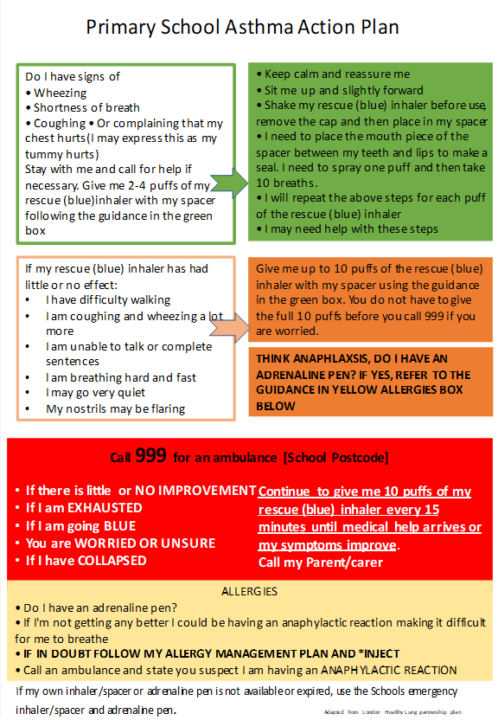
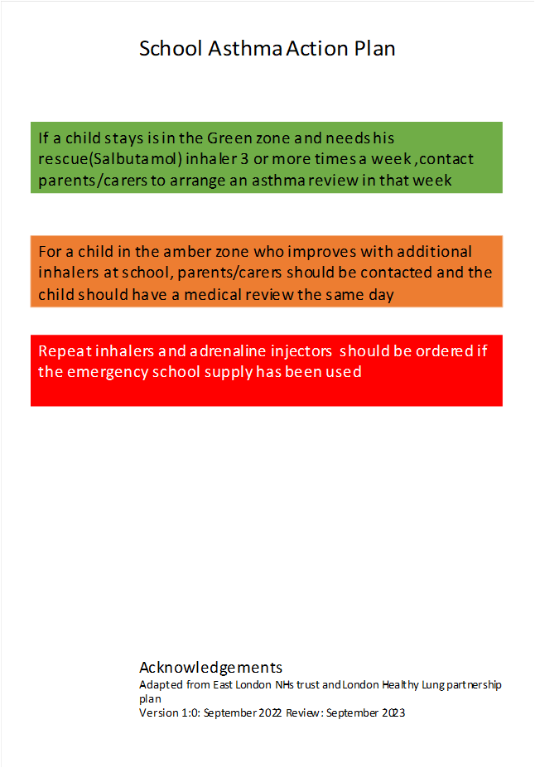

Acknowledgements
Adapted from East London NHS Trust and London Healthy Lung Partnership Plan
Version 1:0 September 2022 Review: September 2025

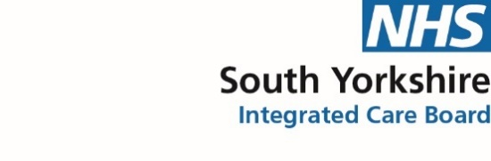Appendix 3

School Name:

Specimen Parent Asthma Letter for Schools

Dear Parents,

This letter is to formally notify you that _____________________ has had problems with their breathing today.
This happened when________________________________________________________

- They used______ puffs of their own inhaler
- They did not have their own asthma inhaler with them, so a member of staff helped them to use the school emergency asthma inhaler containing salbutamol. They were given_____ puffs.
- They have requested to use their rescue inhaler >3 times this week

(Tick whichever box is applicable)

Although they soon felt better, we would strongly advise that you discuss this with their own doctor or asthma nurse as soon as possible.

Yours sincerely,

Signed: ____________________________ Date: _____________________

Print name: ______________________________

Child’s name: ______________________________ Class: __________________

- Please can you ensure your child brings in a working in-date inhaler and spacer for their use in school: both should be clearly labelled with your child’s name and date of birth.

Appendix 4

Ordering Emergency Inhalers for Schools:

- Order on line - Salbutamol Inhaler | Eureka Direct
(https://www.eurekadirect.co.uk/Medical-Consumables/Inhalers-For-Schools/Salbutamol-Inhaler)
This company can supply and deliver inhalers to schools for emergency use.
Schools complete the online order form (https://www.eurekadirect.co.uk/Medical-Consumables/Inhalers-For-Schools/Salbutamol-Inhaler) which acts as the signed order for the inhalers – schools can set up a purchase order number so the company can invoice the schools for payment. There is no minimum order, but they do have a delivery charge of £5.95.

- Order from community pharmacy
Most community pharmacies will be happy to provide supplies based on these Guidelines
(https://assets.publishing.service.gov.uk/government/uploads/system/uploads/attachment_data/file/416468/emergency_inhalers_in_schools.pdf)

The school will need to provide a signed order with the following details:

Sample signed order for the purchase of emergency salbutamol inhalers for use in schools:

Name of school
Address of school
Purpose for which the inhalers are intended | Please supply salbutamol inhalers, as indicated in this signed order, to be held by the school for the emergency treatment of acute asthma
Number of Salbutamol inhalers (Salamol 100mcg pMDI CFC free) | 2
Name of Head Teacher

Signature of Head Teacher

Appendix 5

