**South Yorkshire NHS** Management Office:

722 Prince of Wales Road Sheffield S94EU Contact: [scn-tr.cypalliance@nhs.net](mailto:scn-tr.cypalliance@nhs.net)

July 2023

Dear Head Teacher,

I am writing on behalf of the NHS South Yorkshire (SY) and the Children & Young People’s (CYP) Alliance.

We want to share with you an exciting initiative as part of the Excellent Asthma Care in South Yorkshire Programme (<https://sybhealthiertogether.nhs.uk/parentscarers/easy-asthma>) with the aim to enrol and support all schools in our region to become Asthma Friendly.

The programme will deliver training, resources, and support to schools across South Yorkshire, aiming to improve health outcomes for children and young people with Asthma.

The Asthma Friendly Schools initiative recently started as a pilot in 8 primary and secondary schools across South Yorkshire and we are now in a position to offer the opportunity to every school together providing access to the following resources:

* Asthma Friendly Schools Policy
* National Tier 1 Asthma Training (with a poster to signpost staff to this training)
* School Asthma Action Plan
* Template Register for CYP with Asthma
* Template Parent Consent Letter

The UK has some of the highest death rates in Europe for childhood asthma and health outcomes are even worse for those children and young people living in the most deprived areas. The Asthma Friendly Schools initiative invites schools across South Yorkshire to support the achievement of the following objectives:

* All staff in school to be trained in Asthma Awareness
* Each school to have an Asthma Policy
* Each school to have an Asthma register
* A consistent approach to where and how inhalers are stored in the school
* A notification system of when inhalers are due to expire
* Each school to have a spare emergency inhaler and spacer
* A process in place of when to escalate cases to a health professional and/or parents/carers

The benefits to becoming an Asthma Friendly School are:

* Improving asthma awareness and management in schools
* Improving support to students with asthma by encouraging an inclusive environment
* Supporting responsibilities for the health, safety and well-being of students and staff
* Ensuring the school is implementing current and best-practice asthma management strategies
* Enabling the school to promote its self-accredited status to ensure that the community is aware of the school's commitment to Asthma Friendly Strategies

If you would like to know more about becoming an Asthma Friendly School, please email us on [scn-tr.cypalliance@nhs.net](mailto:scn-tr.cypalliance@nhs.net) and we will connect you with a health professional in your area, who will guide you through the Asthma Friendly Schools pack.

Once your school has achieved the objectives above, you will be presented with our Asthma Friendly Schools Certificate.

We look forward to you becoming a school that is:

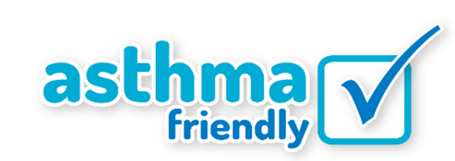

Yours sincerely,

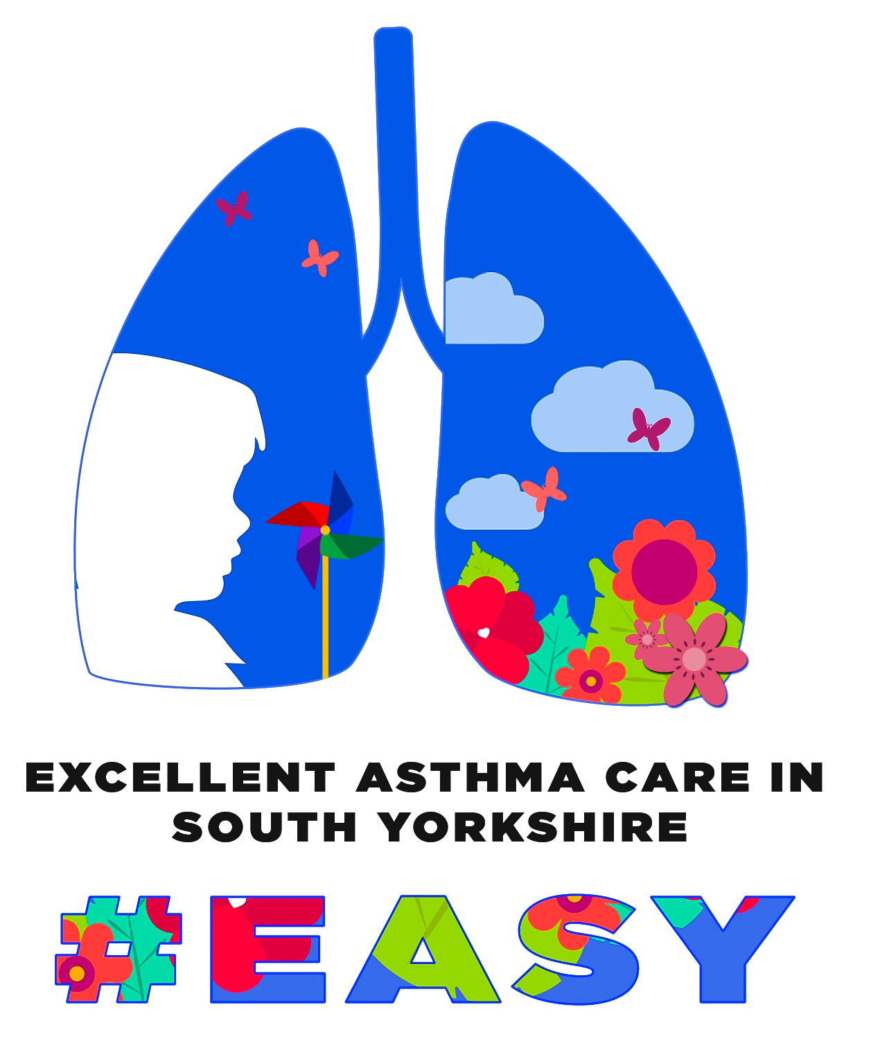

Dr Sonal Kansra

Clinical Lead for the Excellent Asthma Care Programme in South Yorkshire

<https://sybhealthiertogether.nhs.uk/parentscarers/easy-asthma>

Scan this QR code if you would like to join the CYP Alliance