
This is my
Hospital Passport
For people with Learning Disabilities coming into hospital
My Name Is

If I have to go to hospital this book needs to go with me, it gives staff important information about me.
It needs to hang on the end of my bed and a copy should be put in my notes.

This passport belongs to me.
Please ensure that I take it with me when I am discharged
Nursing and medical staff please look at my passport before you do any interventions with me, anybody else; please ask permission before you look at my passport.

The information that is written in red is essential for you to read

NOTE: For those completing the Hospital Passport, Please highlight any essential information in RED
This is an information document NOT a decision making tool

Information within this passport has been gathered from people who know me well with support from the Sharing Caring Project at Sheffield Mencap.

Please check later in this document for when this information was last updated and confirm any important information.

Date this passport was completed:
 | 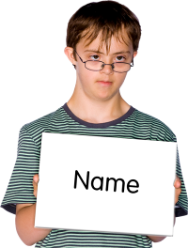 | My full name:  I like to be known as:
 | 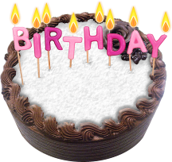 | Date of Birth:
 |  | Address:
 | 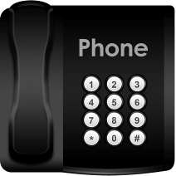 | Telephone Number:
 |  | NHS Number:
 |  | Ethnicity:  Religion and any religious needs
 | 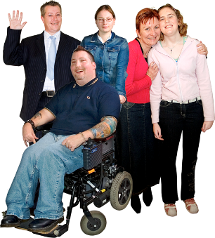 | My next of kin / Emergency contact and their relationship e.g Mum, Dad, Advocate, Friends, support staff:  Address:  Telephone:

 |  | My GP / Practice name:  Address:  Telephone number:  Other services and professionals involved:  The date of my last annual health check:
 |  | My support needs & who gives me the most support:
 | 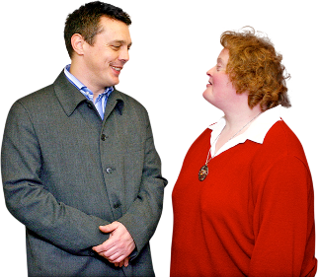 | How I communicate & what language I speak:

Consent: An adult is presumed to have capacity to consent unless proved otherwise. No adult can consent for another. If a person is unable to consent, best interest guidelines apply (Mental Capacity Act 2005). If you are concerned about the person’s capacity to give informed consent, or require any further information, please contact your Local community Learning Disabilities Team on 0114 2262900 or for further information, visit: http://www.signpostsheffield.org.uk/healthy-safe/healthy/laws/mca

 | 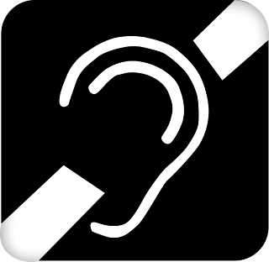 | Sensory information e.g. sight, hearing and touch:
 |  | Allergies:
 | 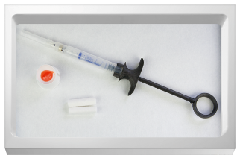 | Medical interventions – How to take my blood, give injections, BP etc:
 |  | Please note: If a person is assessed as being unable to consent, best interest guidelines apply (Mental Capacity Act 2005). Please ensure that this is followed.
 |  | Heart or breathing problems:
 |  | Risk of choking, Dysphagia (eating, drinking and swallowing):
 | 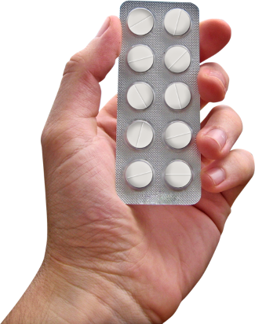 | Current prescribed medication I take and what it’s for:
NOTE: This is correct at the time of writing which is:
This information was collected from:
Please check that this is still correct!
 |  | My diagnosis, medical history and treatment plan:

 | Admitting Me
 | 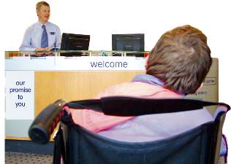 | On admission, please notify my Key Contact and Key Health contacts (please see back pages of this document)

 | 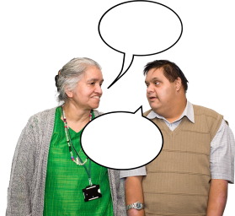 | How to communicate with me:
 | 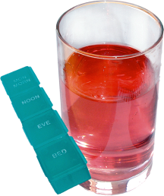 | How I usually take medication (tablets, injections, liquid):
 | 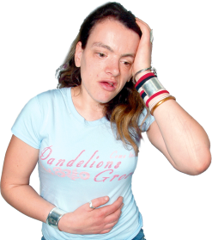 | How you know I am in pain and where is it:
 | 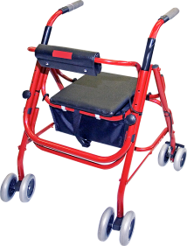 | Moving around (posture in bed, walking aids, transferring):
 | 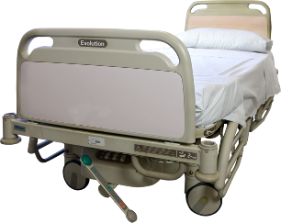 | Pressure care (any support I need with this):
 | 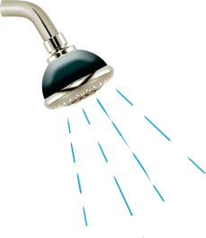 | Help I need with personal care (washing, dressing etc):
 | 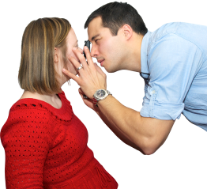 | Seeing / Hearing (Problems with sight or hearing):
 | 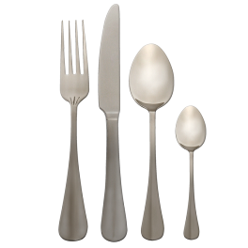 | How I eat (Help to cut up food, risk of choking, other help to eat):
 |  | How I drink (Usual quantities, thickened fluids, likes, dislikes):
 |  | How I keep safe (bed rails, support with challenging behaviour):
 | 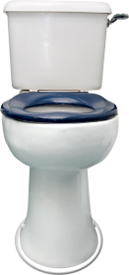 | How I usually use the toilet (Continence aids, help getting to the toilet):
 |  | Sleeping (Sleep pattern / routine):

Discharging Me
Please do not discharge me without speaking to my key contact and checking that the relevant health contacts have been contacted (please see back page)

Likes: For example – What makes me happy? What do I enjoy doing i.e. watching TV, reading, listening to music, my routines, talking to people etc

Dislikes: For example – What makes me sad? What do I not like, i.e. Shouting, being told what to do, food I do not like, physical touch etc
 | 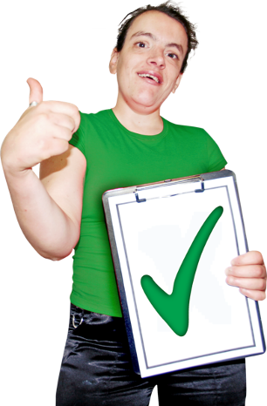 | Things I like (please do these):
 |  | Things I don’t like (Don’t do these):

This section of my passport is detachable. When completed, a new sheet needs to be used every time I am admitted into hospital.
Please retain all documents for my records
The Matron has been informed of my support needs to ensure my safe admission and transfer to the ward
 | Matrons name:  Matron sign:  Admission date: | Ward manager’s name:  Ward manager sign:  Admission date:
 | My support staff notes (My support staff are asked to detail below communications they have with any other Health Care Professionals during my stay and admission. Each entry should be signed and dated):
Please contact my key contact for any further information you require about me and support I need

My Key contact is:

Their telephone numbers are:

Notes:

 |  | Community Learning Disability Team  33 Love Street  Sheffield  S2 8NW |  | 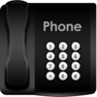 |  | 0114 2262900
 | Health Contacts |  |  | Please check my Key Contact has informed the relevant Health Contact when I am discharged
 | Name of Health Contact |  | What area of Health does this person help me with (e.g. physio) |  | Contact Details

Updating my passport
Please put the date you checked this passport and the date it was updated. Please
include your name and any relevant contact details
 | The date this was last checked | Date updated  (if updated) | Name of person that checked and updated this passport

*Blank Page*

 | Please display this page so that all hospital staff and visitors can see it, e.g. on the wall next to my bed
 | 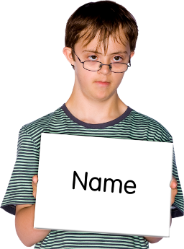 | Hello, my name is:
 | 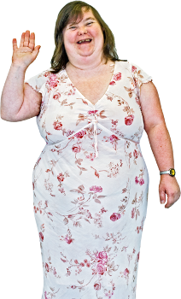 | How I say hello:
 |  | How I drink / say I would like a drink and MY FAVOURITE DRINK:
 | 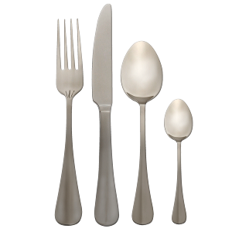 | How I eat / say I am hungry:
 |  | How I show I am happy or unhappy:

